Meal Manage – Adding funds to an account

Meal Manage

To Add Money to a Student Account (Optional) – this is primarily for high school students.

- Log in to Meal Manage
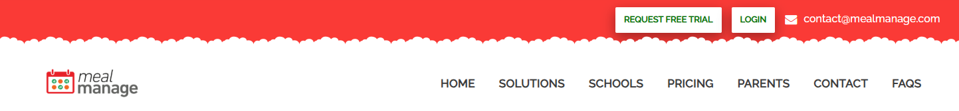

- Click “go to dashboard”
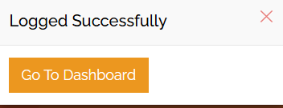

- A new window will pop up to register your device. You will see a request to send a verification code as in the image below. Select email or mobile. Then “request code”.
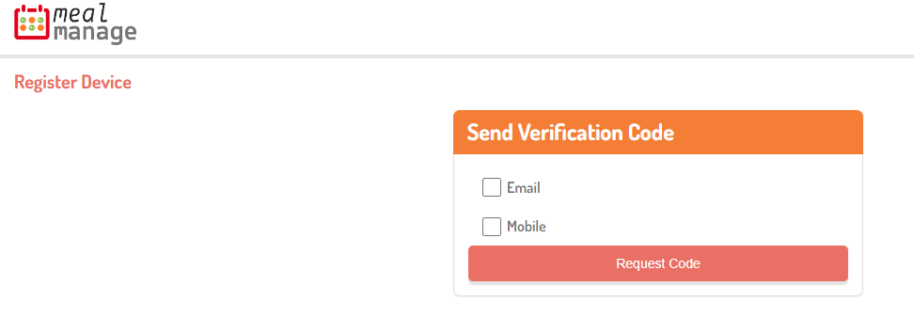
- The code will be sent by email or mobile. A new box will appear with a box to enter the verification code. Click “validate”.
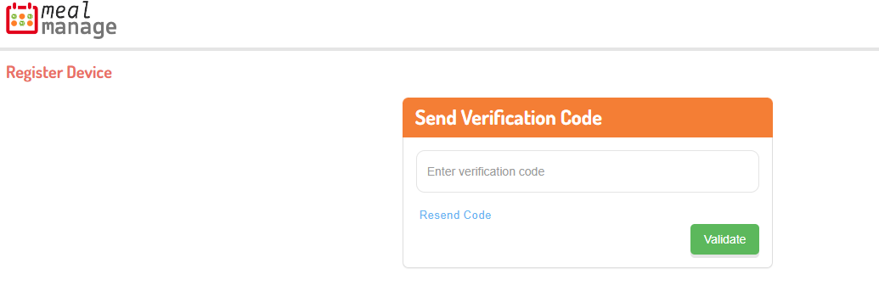

- When you log in, all student accounts connected to the email address will show up. To show up, click “add balance”
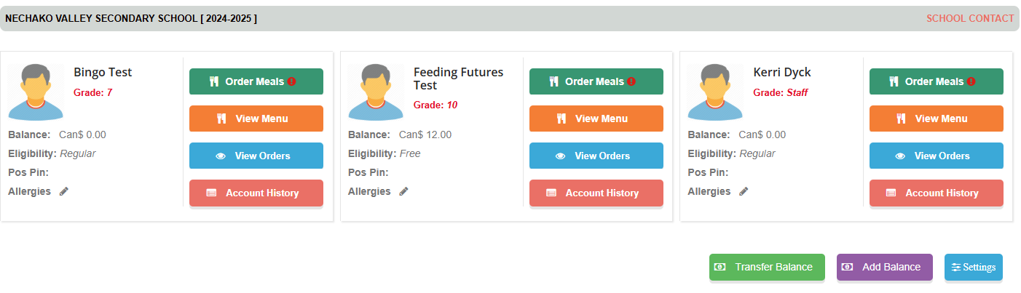
- Enter the dollar amount you want to add. You may share the amount with multiple students. Then go through the steps of paying with a debit or credit card.

Payment Options:
- Credit Card (Visa/Mastercard), debit card or pre-paid credit cards
  - When adding funds in Meal Manage, credit card and debit payments are available. The system uses Stripe as the payment processor.
- Cash or cheque
  - If paying by cash or cheque, please bring the money to the school. Make cheques out to “School District 91 (Nechako Lakes)”, note ‘food program’ in the memo line.

