Meal Manage – Set up an account

Meal Manage

Here's how to get started...
- Go to the link for your school and enter the email address the school has on file. If there is an error, please check the school has the correct email address.
  - Evelyn Dickson Elementary
  - Fraser Lake Elementary-Secondary School
  - Nechako Valley Secondary School
  - Lakes District Secondary School
  - Sinkut View Elementary School
  - W.L. McLeod Elementary School
- A link to join Meal Manage will be emailed to you. Click on “Go to MealManage” to create an account.
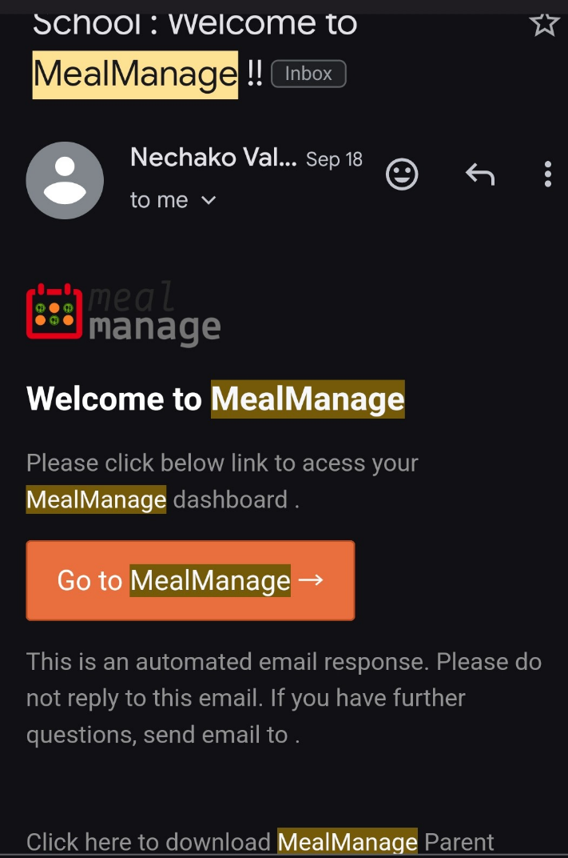
- A new window will pop up to register your device. You will see a request to send a verification code as in the image below. Select email or mobile. Then “request code”.
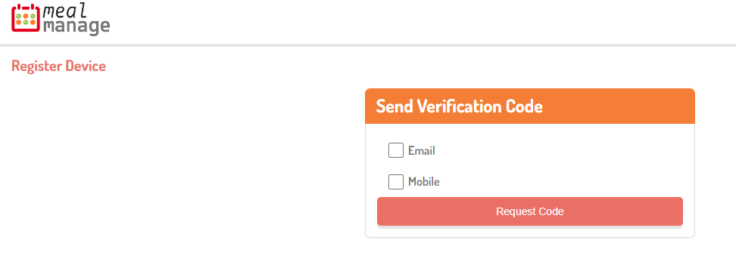
- The code will be sent by email or mobile. A new box will appear with a box to enter the verification code. Click “validate”.
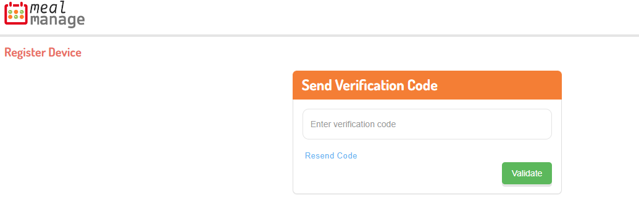
- You now have an account!

You will see the option to order meals, view order, and account history.
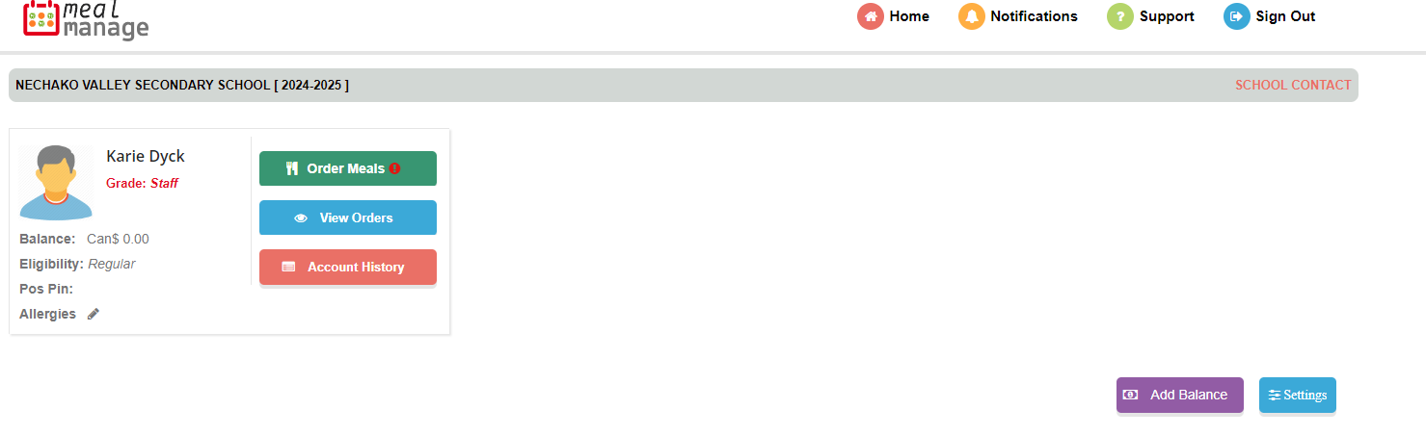
**Optional**: On the student account image there is a line for “allergies”. Click on the pencil icon. A window will pop up, select the allergens to add to the file. Scroll down and select “save”.
