Meal Manage – Frequently Asked Questions

- I am having issues signing up, who do I contact?
  - Email rturnerklopper@sd91.bc.ca. Robyn is the Food Program manager with the school district and will happily help set up accounts.
- My internet is poor or I cannot use the website.
  - No problem! Please visit the school, they can assist with adding funds to accounts. However, only cash and cheque may be paid at the school.
- How do I set up my account with multiple students?
  - Accounts are pre-set up using the email the school has on file. On log in, each student should show up that is connected to the email address. If there is a student missing from your account, or the email address is not working, please let us know. The email may be incorrect on our side.

  - When adding funds, click “add balance”, the following screen appears:
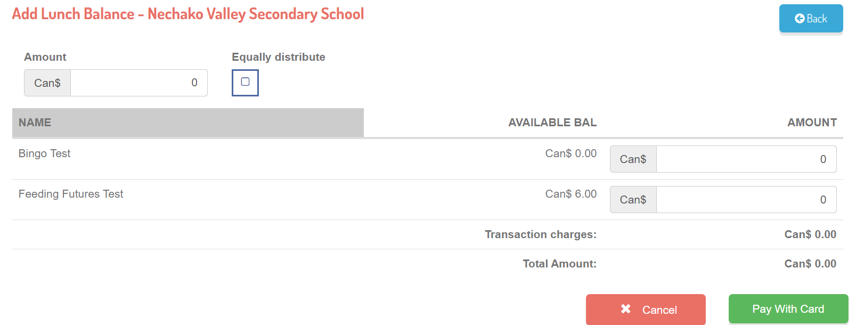
Enter the amount to be added. You can set an amount to add for each student, or pay a lump sum and have the system equally add to each account. Then select “pay with card”.

With multiple students, on the main screen, there is a button “transfer balance”. If one student has funds, and you need to move funds to another student, please click this button. And follow the steps.

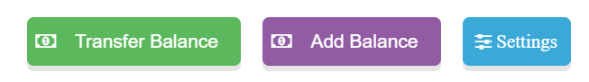
- What happens if there is a balance on the account at the end of the year?
  - It rolls over to the next school year.
- Can two emails be on one student account? For example, students who have multiple care providers.
  - Yes, each student account has a primary and alternate email. If an alternate email needs to be added please email rturnerklopper@sd91.bc.ca or tell the person at the front desk at the school.
  - This can be helpful if two different people need access to one student account.
- Where is data collected by Meal Manage stored?
  - All data is stored in one of the AWS global servers, which is cloud based. A full privacy statement can be made available.
- Where do I find more information about Meal Manage?
  - https://www.mealmanage.com/

