Meal Manage – Pre-order of meals

Meal Manage

- Log in to Meal Manage
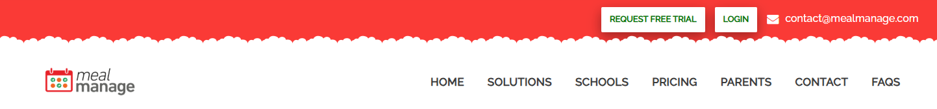

- Click “go to dashboard”
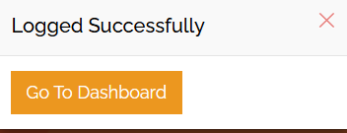

- A new window will pop up to register your device. You will see a request to send a verification code as in the image below. Select email or mobile. Then “request code”.
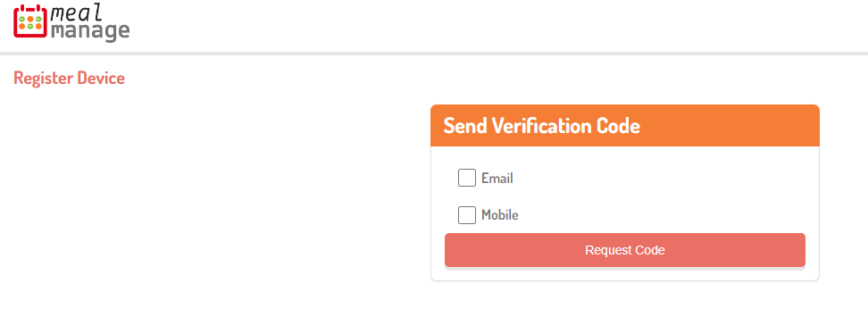
- The code will be sent by email or mobile. A new box will appear with a box to enter the verification code. Click “validate”.
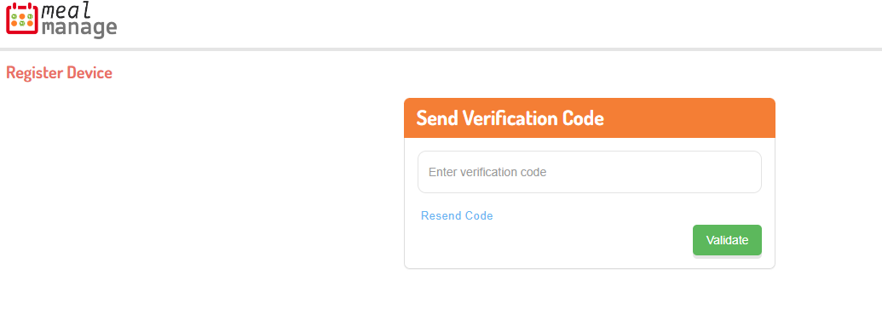

- When you log in, all student accounts connected to the email address will show up, for example:

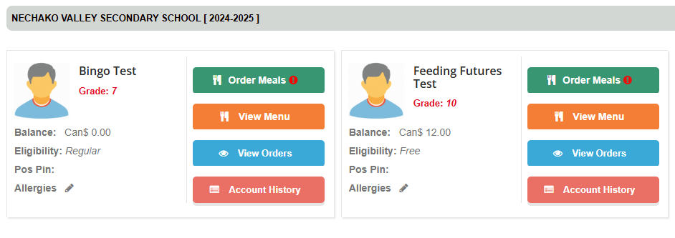
- Click “order meals”
- A calendar for the month will show up. Click on the items the student wants to be added to the cart. If an item is in red, it means the menu item contains a listed allergen. Where possible, food allergens will be accommodated if the school kitchen has at least 24 hours notice.

On the calendar, there is a food item, for example “spaghetti”, and “Feeding Futures” listed. To continue offering a pay-what-you-can lunch program, the “Feeding Futures” item is listed so households can select how much they can pay for lunch each month.

The lunch program is at the school for each child to be able to access nourishment at school to be ready to learn. If there is something that can be done to make the program more accessible, please let us know.

- Once all menu items are selected, click “review order”
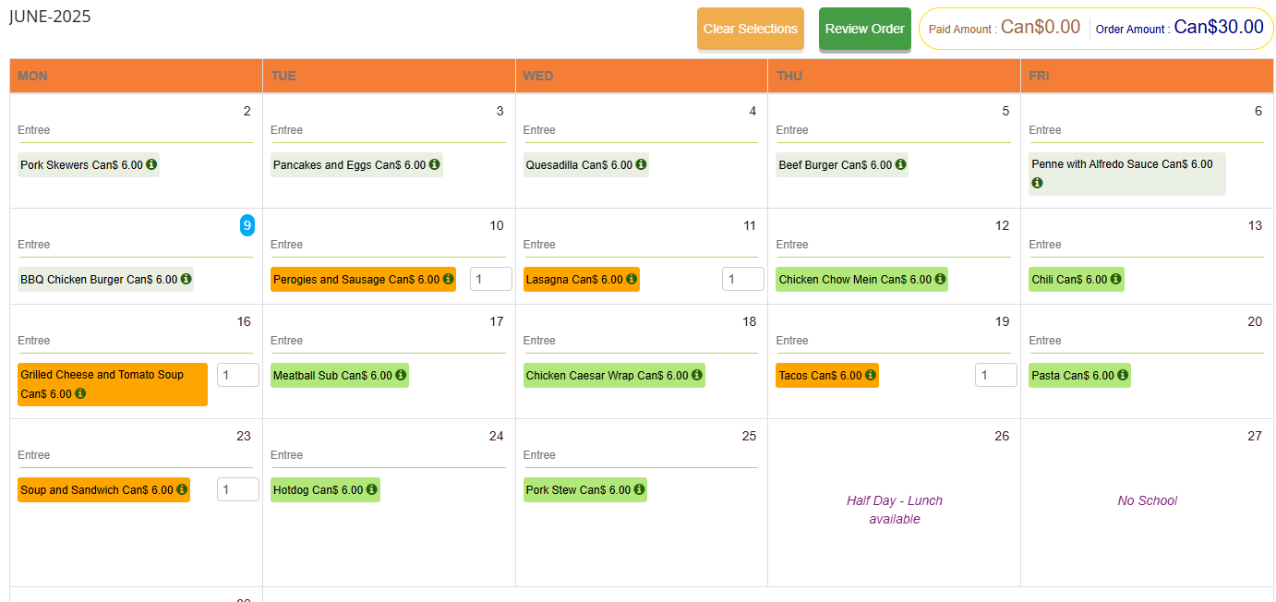
- Confirm items, then click “go to payment summary”
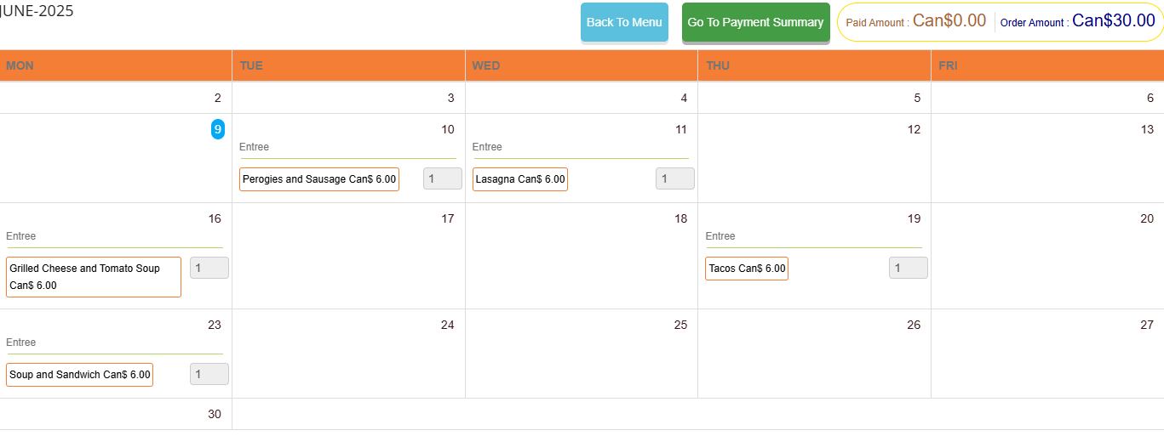
- If money is on the account, the order can be paid with the “meal account balance”
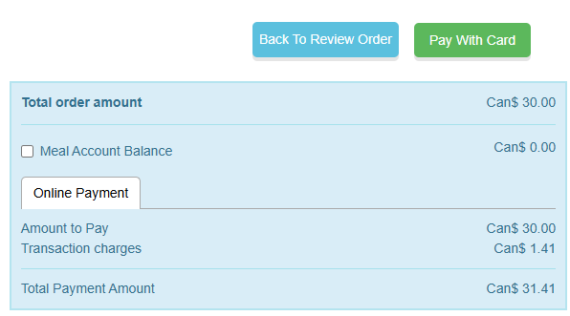
- Otherwise, select “pay with card”. If choosing to pay with cash or cheque, please bring money to the school and it will be added to the account. Cheques can be made out to “School District 91 – Nechako Lakes”, note: food program in the memo line.
- Enter the debit or credit card information, and follow the prompts to complete payment.

Thank you for participating in the school food program.

